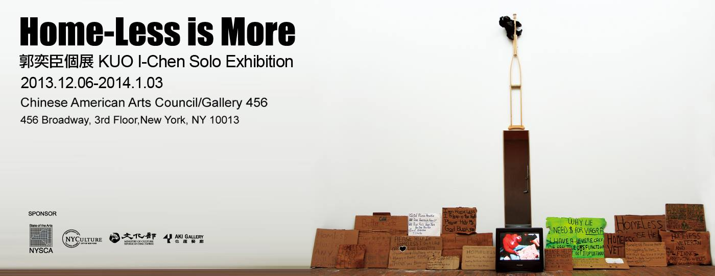
台灣的藝術家郭奕臣，曾代表台灣參加2005威尼斯雙年展台灣館，並為歷年來參展最年輕的藝術家，作品曾在新加坡雙年展，雪梨雙年展，首爾國際媒體藝術雙年展與德國ZKM美術館…等重要美術館展出，作品並持續獲邀於歐美各國等地展出，此次為郭奕臣首次在紐約舉辦個展。郭奕臣的作品不斷透過不同的媒材型式，創造出一種詩意兼具情境式的獨特語彙，作品的核心關注於環境與內心歸屬感的消逝與飄盪的精神狀態，並透過不存在的狀態去顯現對生命本質的探索。
Taiwanese Artist KUO I-Chen was the youngest participant of Venice Biennale in 2005. He was invited to various important museums and biennales such as ZMK, Singapore Biennale, Sydney Biennale, Seoul International Media Biennale…etc and keeps being invited by museums internationally. This is KUO’S first solo exhibition in New York. He uses different media to create a poetic contextual artistic language. He investigates the nature of life by paying close attention to environment, the sense of belonging, and the state of mind that has vanished.
此次展出兩件新作，是藝術家於今年在紐約駐村所創作，《Soul Out》將紐約地鐵軌道的垃圾當作再次消費的物件，藉由消費行為的重建，反應人類在這種資本主義體系中被無意識地操作與無法逃避的現實無力感。《Home-Less is More》以紐約街頭上隨處可見的流浪漢與華麗高聳的現代主義與裝飾藝術的摩天高樓矗立建構出紐約的另類景觀，藉由Homeless文字上的字義與現代主義的精神Less is More，重新解構成一組新的字義“Home-Less is More”，透過交易購買流浪漢其書寫的紙板，重新拼湊成裝飾藝術（Art Deco）的經典建築—帝國大廈與流浪漢所書寫的字版，建構出藝術家眼中的紐約天際線，試圖揭露在極度裝飾的華麗外表下，顯露的卻是不堪殘破的陰影，而這陰影卻是來自真實世界的美國夢。
This time KUO will present two new works created during his residency in New York. The first one reuses trash in New York subway as consumer goods, reflecting human’s manipulated unconsciously and lacking of sovereignty under Capitalism. On the other hand, the second one puts the everywhere homeless people together with modern decorated skyscrapers, forming a special scenery. By deconstructing the word “homeless” and combining it with modernistic phrase “less is more”, KUO develops a new meaning and the title “Home-less is more”. In the project, he purchased cartons from homeless people and used them to build the classic Art Deco style decorated building The Empire State building model. Forming a skyline in the artist’s mind, KUO reveals the dilapidated darker side of luxurious ostentatious appearance which comes from the real life American dream.
此外，藝術家也精選過去多件作品，以追溯作品中對於歸屬感以及生命本質探索的脈絡:從《入侵》透過一個巨大不存在的飛機影子，穿透聯結了內/外的空間，《失訊》藉由在城市中飄離的氣球，這兩件作品都精準地傳達屬於生活在城市裡現代人的集體焦慮感與不斷游離的精神狀態，《Survivor Project》透過真實新聞災難性的照片，藉由影像的重新拼貼，建構出一種過去式的未來寓言，《序》在海邊不斷被海風吹拂飄散的白紙，書寫出屬於每個人的心底記憶，《Shadow of Light》則透過聖經創世紀提到「God said, Let there be light: and there was light」，藝術家使用凸透鏡聚焦太陽的光源聚焦於聖經文字上的光“Light”一字逐漸起火，最終整本聖經消融於灰燼，並用倒敘的方式讓聖經於灰飛煙滅中重生。《Snapshadow》使用智慧型手機Spy Cam軟體觀看著地球上某處即時監視器畫面，透過攝影者不存在的方式而所拍攝完成的『攝影作品』。
Additionally, in order to better posit Chou’s investigation of the nature of life and the sense of belonging, a selection of his earlier works will also be presented, accompanying the two most recent projects. From the work connecting inside and outside by a huge airplane shadow and sending images back from a floating balloon, both works accurately convey the collective anxiety and drifting state of mind of human in a modern city. Then creates a future prophecy by collage pictures of past catastrophe news and depicts the deepest memories in everyone’s heart by papers at seaside fluttering by wind. Also in the work KOU inspired by the phrase in Bible “God said, Let there be light: and there was light”. KOU uses a convex to let the word “Light” on the bible to burn, and whole bible is burned to the ground. KUO records this burning process, and reverse it in order to let the bible reborn from the ash. KUO shots “photos” which photographer is not at presence by using APP SPY Cam on smart phone to supervise someplace on earth.
For more information, please visit http://caacarts.org and http://www.kuoichen.net/

